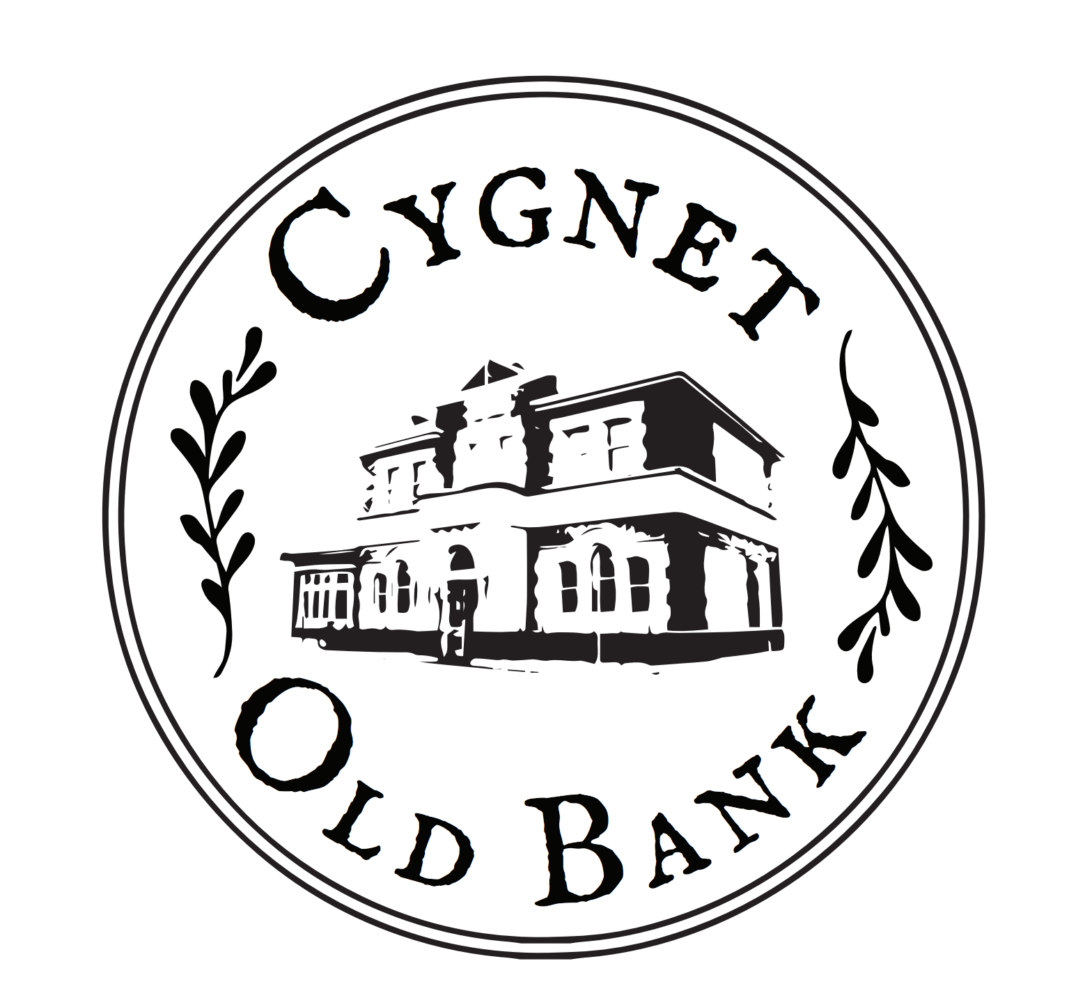
PAYMENT
The accommodation fee is payable in advance at the time of booking.
You can either pay by Electronic Funds Transfer (details below) or by credit card.
We accept Visa and MasterCard and you can either enter the details above or we can arrange payment over the phone (just call on 0418950587).
Please note there is a 1.9% surcharge for Visa and Master cards and 2.9% for Amex and Diners credit card payments.

FUNDS TRANSFER DETAILS
If you prefer to transfer funds by EFT our bank account details are:
Account Name Sharon Ireland (Cygnet Old Bank)
BSB 067-009
Account Number 1004 2477

TERMS & CONDITIONS
By making a booking at the Cygnet Old Bank, you acknowledge that you have read, understood and accepted the Terms and Conditions set out on this website and that you have read this section: TERMS & CONDITIONS.
SMOKING POLICY:
This is a smoke free property
OUR GUESTS
Only booked (and pre-paid) guests may stay overnight at the Bank.
Your visitors are welcome but should unauthorized guest stay overnight, you will be charged an extra $100 per night per person at our sole discretion .
If a booking is terminated by us for any breach of the Terms and Conditions applying at the Cygnet Old Bank, or for aggressive or antisocial behaviour at any time (to be determined by us at our sole discretion), then the balance of the tariff paid for the accommodation at the time of booking (if any) will not be refunded. And you will be asked to leave forthwith.
NO PARTY & DAMAGES POLICY
To ensure peaceful enjoyment at the Cygnet Old Bank for us, our other guests and our neighbours, we have a strict "no party" policy.
Should this fundamental condition of occupancy be breached by you and/or the property is left in a dirty, damaged or unreasonably untidy state at the conclusion of your booking (to be determined by us at our sole discretion), you will be charged a cleaning fee of a minimum of $500, plus the full replacement cost of any damaged or lost items of equipment and/or furnishings.
PAYMENT POLICY
To confirm your reservation, full payment must be made at the time of booking via EFT or credit card (VISA or MasterCard); contact Cygnet Old Bank for details on 0418950587 or see the Booking page.
By making full payment when you book, it is expressly understood by us and by you that you have read, understood and accepted our Terms & Conditions.
CANCELLATION
For a full refund of accommodation fees less booking fee, cancellation must be made five full days prior to listing’s local check in time on the day of check in.
If the guest cancels less than 5 days in advance, the first night is non-refundable but 50% of the accommodation fees for the remaining nights will be refunded less the booking fee of $20.
If the guest arrives and decided to leave early, 50% of the accommodation fees for the nights not spent less the booking fee will be refunded.
If the guest does not arrive on the day of the booking, no repayment of the booking payment will be made.
We encourage you to purchase travel insurance to cover any unforeseen circumstances.
We, the owners, reserve the right to change these Terms & Conditions at any time without prior notice.

